Supplier Code of Conduct
REV0, April 2026

This document and the information contained herein is the sole and exclusive property Achates LLC dba Checkered Past Machine, and any use, reproduction, or copying thereof in whole or in part without the express written permission of Achates LLC dba Checkered Past Machine is strictly prohibited. © 2023 Achates LLC dba Checkered Past Machine. All rights reserved.

Contents

Introduction 2
Labor and Human Rights 2
- Forced and Child Labor
- Human Trafﬁcking
- Wages and Working Hours
- Fair Treatment, Non-Discrimination, and Diversity/Inclusion
Health and Safety 3
- Occupational Health and Safety
- Environmental Considerations
- Hazardous and Restricted Substances
Ethics and Compliance 4
- Import/Export and Sanctions Compliance
- Conﬂicts of Interest
- Anti-Corruption and Anti-Trust
- Intellectual Property
- Financial Integrity, Records and Accounting
- Anti-Money Laundering Compliance and Reporting
- Data Privacy, Information and Cybersecurity

Quality 5
- Counterfeit Parts
- Responsible Sourcing and Conﬂict Minerals
- Quality Assurance Process

Reporting Concerns 5

Introduction
Achates LLC dba Checkered Past Machine (Achates) is an American manufacturer, technology developer, and innovation partner for defense, aerospace, and related industries. Built on a legacy of world-class additive manufacturing, jet engine design, and American-based production, our team maintains more than 700 years of combined experience developing groundbreaking innovations. We’re uniquely equipped to solve complex problems and pride ourselves on an ability to tackle each new challenge from the ground up.
The Supplier Code of Conduct (the “Code”) applies to all Achates suppliers of materials, products and/or services, including their subcontractors, agents, representatives, suppliers, third party consultants, and employees, regardless of the materials, products and/or services provided to Achates (collectively “Suppliers”). This Code aligns with our own company values and ethical guidelines.
As a condition of doing business with Achates, we expect all subcontractors and suppliers to comply with the Code and to operate in accordance with the values comparable to ours. Suppliers must adhere to all applicable laws, legal regulations, directives, and guidelines. Suppliers must follow established Achates procurement rules and procedures, including relevant Quality clauses.

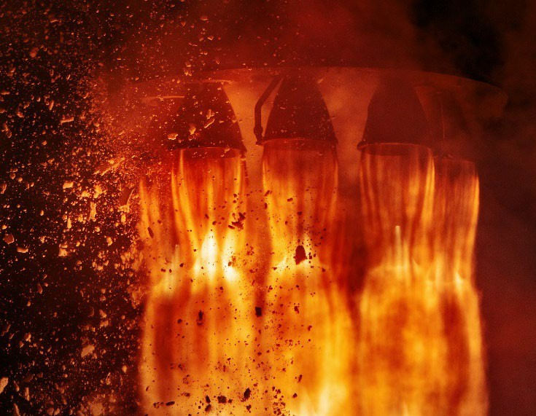


Labor and Human Rights
We expect all our suppliers and subcontractors to treat their workers with respect and dignity and to foster a work environment free of harassment and intimidation.

Forced and Child Labor
Suppliers shall not use any type of forced or involuntary labor, to include indentured, bonded, or prison labor, in the performance of work for Achates.
Child labor is strictly prohibited. We expect all suppliers to ensure that child labor is not used in during the performance of work nor used in any part of the product supply chain. The minimum age for employment is 18. or under the minimum age for employment in the country. This Code does not prohibit the participation in legitimate and lawful workplace apprenticeship or internship programs.

Human Trafﬁcking
Suppliers shall not engage in any type of human trafﬁcking, exploitation or other activities that may allow for control through coercion or procure or supply goods tainted by human trafﬁcking. Suppliers shall be honest and forthright in all domestic and international recruiting activities and abide by all relevant immigration laws and regulations.

Wages and Working Hours
Suppliers shall pay all workers at least the minimum wage required by applicable laws and regulations. Suppliers shall always comply with all maximum working hour laws and provide the appropriate compensation as required by laws and regulations related to overtime pay.

Fair Treatment, Non-Discrimination, and Diversity/Inclusion
Achates expressly prohibits any form of unlawful team member, supplier, or subcontractor harassment or discrimination based on race, color, creed, religion, national origin, ancestry, citizenship status, age, sex or gender (including pregnancy, childbirth, and pregnancy-related conditions), gender identity or expression (including transgender status), sexual orientation, marital status, military service and veteran status, physical or mental disability, genetic information, or any other characteristic protected by applicable federal, state, or local laws.
Achates expects suppliers to engage in equal employment opportunity best practices. Equal employment opportunity applies to all terms and conditions of employment, including hiring, placement, promotion, termination, layoff, recall, transfer, leave of absence, compensation, and training.

Health and Safety
Suppliers are expected to maintain a safe work environment, including but not limited to proper use of equipment, avoidance of unsafe and unhealthy practices, protection of the local and global environment, and adherence to all applicable laws and best practices as it relates to ensuring the safety of all employees.



Occupational Health and Safety
Suppliers and subcontractors shall take all measures possible to ensure the health and safety of their employees, to include the provisioning of all required training and the maintenance of a company health and safety program.
Suppliers and subcontractors assume responsibility for addressing and controlling employee safety and health hazards in accordance with applicable laws, regulations, policies, and best practices.


Environmental Considerations
Suppliers shall operate in an environ- mentally sustainable manner, with special consideration taken to minimize
the environmental impact on the local and global communities. Suppliers shall abide by all domestic and international environmental laws and regulations when conducting business or in performance of work, including but not limited to obtaining environmental permits and registrations as required.

Hazardous and Restricted Substances
Our Supplier’s materials and products must meet regulatory quality and safety standards, in addition to Achates’s internal quality standards, policies, speciﬁcations, procedures and contract requirements.
Suppliers are expected to comply with all relevant laws, regulations, and other requirements when handling or using hazardous materials. All hazardous materials must be identiﬁed and managed to ensure safe handling, use, storage, movement, recycling, and disposal.
The unlawful use, possession, purchase, sale, or distribution of or being under the inﬂuence of any illegal drug or controlled substance while on company or client premises or while performing services for the company is strictly prohibited. Achates also prohibits suppliers and subcontractors reporting to work or performing services under the inﬂuence of alcohol or consuming alcohol while on duty or during work hours.

Ethics and Compliance
Suppliers must perform any work for Achates ethically and in full compliance with all applicable laws, regulations, and contract requirements.
Gifts or entertainment must be modest in value, infrequently provided, and consistent with local law and the internal rules of the recipient’s employer, and must not, by their quality, quantity or timing, be used by Suppliers to gain improper advantage or preferential treatment from Achates employees or others on behalf of Achates’s business interests.

Import/Export and Sanctions Compliance
Achates expects full compliance with relevant import/export controls regulations and sanctions restrictions. Suppliers are not permitted to work with individuals, entities, or government organizations subject to economic trade sanctions administered by the UN Security Council, the United States, Canada, or the European Union.
Suppliers shall inform Achates of the export control classiﬁcation of their products upon request. Suppliers shall provide complete and accurate information and obtain the appropriate export licenses or authorizations as necessary.

Conﬂicts of Interest
Suppliers are required to avoid any real or perceived conﬂicts of interest at both an individual and organizational level. Suppliers are expected to report any situations that may present a conﬂict of interest to Achates Legal for evaluation and mitigation. Some examples of situations that could create conﬂicts of interest include:
- Loans or favors that a Supplier, a worker, or a family member receives through their relationship with Achates;
- Business opportunities that belong to Achates; or
- Improper advantages gained by Supplier acting on information learned through their relationship with Achates.

Anti-Corruption and Anti-Trust
Achates has a zero-tolerance policy for corruption and expects suppliers to not make any illegal, improper, or corrupt payments. Suppliers must comply with the applicable anti-corruption laws in the countries that they do business and in accordance with the United States Foreign Corruption Practices Act (FCPA).
Achates expects suppliers and to conduct business fairly and ethically, and in full compliance of all applicable antitrust regulations. Suppliers must compete on the merits of their products and services and must not participate
in any activity that may unfairly and unlawfully restrain trade or competition.

Intellectual Property
Achates strives to preserve the conﬁdentially of all company and third-party information in accordance with business
and industry best practices and applicable laws and regulations. Suppliers must protect all conﬁdential, proprietary information, electronic data, intellectual property, know-how or trade secrets of Achates with appropriate safeguards. Suppliers are required to respect and protect the intellectual property rights of Achates and third parties. Achates and other third-party information provided to Suppliers shall not be used for any purposes other than the contractual scope of work.

Financial Integrity, Records and Accounting
Achates relies on its books and records to report its ﬁnancial results, make required legal ﬁlings, and make business decisions. Supplier must keep accurate books and records of all business dealings with Achates. These records must be maintained in accordance with applicable standard accounting practices. If Supplier knows of any actual or potential ﬁnancial accounting irregularity/issue related to Achates, you must report your concerns to Achates.

Anti-Money Laundering Compliance and Reporting
Suppliers must not engage in any form of money laundering, which includes disguising or concealing the nature, location, source, ownership or control of unlawfully obtained money, or transforming such money into legitimate funds.

Data Privacy, Information and Cybersecurity
Suppliers who collect, receive, store or otherwise process personal data in connection with the products and/or services provided to Achates must appropriately handle and protect such data, and comply with all laws, regulations and agreements with Achates applicable to the processing of such data.
Suppliers are required to maintain adequate security standards and systems to safeguard any controlled or conﬁdential data provided by Achates. Suppliers shall have policies and procedures in place to prevent the unauthorized access to Achates or third-party information.
Suppliers are required to report any breach, hack, disruption, or other unauthorized access of Achates information to Achates immediately.

Quality

Counterfeit Parts
Achates is committed to providing high quality materials and products to our customers. Suppliers are expected to develop and maintain standards and other procedures to minimize the risk of counterfeit parts and materials entering the supply chain.

Responsible Sourcing and Conﬂict Minerals
Suppliers must maintain sufﬁcient knowledge of input materials and components to ensure that they were obtained from permissible sources in compliance with all relevant laws and regulations, including the ﬁnal rule regarding the use of “Conﬂict Minerals” under Section 1502 of the Dodd-Frank Wall Street Reform and Consumer Protection Act.
Suppliers are expected to implement OECD-based supply chain due diligence processes to ensure that products containing conﬂict minerals (speciﬁcally tin, tantalum, gold, and tungsten) are responsibly sourced and are not linked to the ﬁnancing of armed conﬂicts or associated entities. Suppliers are expected to cooperate with Achates, in good faith, to complete any applicable annual conﬂict minerals reporting.

Quality Assurance Process
Suppliers are expected to maintain a quality assurance process that allows for identiﬁcation of quality defects and the rapid implementation of corrective actions. Suppliers and subcontractors are expected to always deliver a product that meets or exceeds contract requirements.

Reporting Concerns
Suppliers that have information about a violation or suspect a violation of this Code have a responsibility to promptly report it. This includes reporting information about the potential misconduct of a Achates employee. If allowable in the country where the report is lodged, the report can be made anonymously. Suppliers can report a known or suspected misconduct or raise an ethical concern to the Achates Ombudsman through email address: speak-up@ Achatesind.com.
Achates takes compliance with this Code quite seriously and reserves the rights to assess and monitor Supplier’s compliance with the Code. Violations by Suppliers of this Code will result in a review of our business relationship, up to and including termination of the relationship according to our contractual rights and applicable law.



